**PERFORMANCE TESTING LIFE CYCLE:**

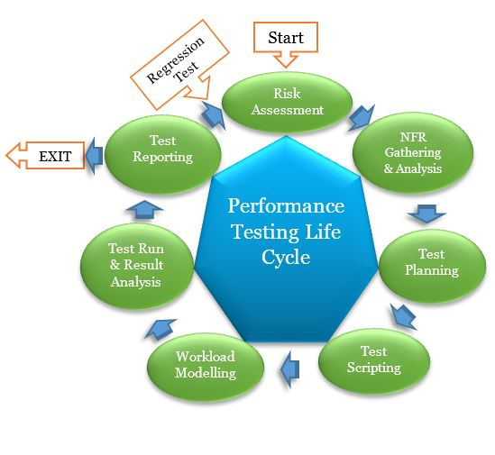

**Phases of Performance Testing Life Cycle:**

PTLC defines different phases of performance testing from risk assessment to test result analysis. It bridges the gaps between the expected result and actual result (only related to performance testing) which helps to deliver a responsive application with better performance.

A quick summary of PTLC phases:

1. **Risk Assessment**

* Purpose: To check the eligibility of the components for performance testing on the basis of a risk score.
* Accountability: Performance Test Lead/Manager
* Deliverable: Performance Testing Risk Assessment Document

1. **Requirement Gathering & Analysis**

* Purpose: To understand the client’s expectation and conclude the requirements
* Accountability: Performance Test Lead/Manager
* Deliverable: Non-Functional Requirement Document (Performance Testing Requirement Document)

1. **Performance Test Planning**

* Purpose: To prepare test strategy as per Non-Functional Requirement
* Accountability: Performance Test Lead/Manager
* Deliverable: Performance Test Plan Document

1. **Performance Test Design (Scripting)**

* Purpose: To create the test scripts as per the approved Performance Test Plan
* Accountability: Performance Test Team Members (Engineer (Create)/Analyst (Create)/Lead (Create/Review)/Manager (Review))
* Deliverable: Performance Test Scripts

1. **Workload Modelling**

* Purpose: To create the workload scenario as per the approved Performance Test Plan using test scripts
* Accountability: Performance Test Team Members (Engineer/Analyst)
* Deliverable: Performance Test Scenarios

1. **Performance Test Execution & Result Analysis**

* Purpose: To execute the performance tests as per timelines documented in the approved Performance Test Plan and analyse the test results
* Accountability: Performance Test Team Members (Engineer/Analyst)
* Deliverable: Individual Test Results

1. **Reporting and Recommendation**

* Purpose: To prepare and publish the test report and provide the recommendations
* Accountability: Performance Test Lead/Manager
* Deliverable: Final Performance Test Report